Preliminary Design Document
for “Drone”
Version 1.0
Jennifer and Annie
Oct 27, 2024

Table of Contents

Table of Contents 2
1. Introduction 3
1.1 Project Overview 3
2. Product Design 4
2.1 Block Diagram 4
2.2 Sub-Circuit Descriptions 4
2.2.1 Sub-Circuit #1: ESCs (Electronic Speed Controllers) 4
2.2.2 Sub-Circuit #2: ESCs, Motors, and Propellers 5
Battery 6
2.2.3 Sub-Circuit #3: Raspberry Pi Pico and Active Buzzer 6
2.2.4 Sub-Circuit #4: Raspberry Pi Pico and MPU-6050 7
2.2.5 Sub-Circuit #5: RF transceivers 7
2.2.6 Sub-Circuit #6: Raspberry Pi Pico, RF transceiver, and SPI 8
SPI Communication 9
2.2.7 Sub-Circuit #7: Arduino Leonardo and RF Transceiver 9
2.2.8 Sub-Circuit #8: ESP32 CAM-MB 10
2.3. Product Interfaces 10
2.3.1 Internal Interfaces 10
2.3.1.1 Raspberry Pi Pico and ESCs 10
2.3.1.2 ESCs and Motors 11
2.3.1.3 4s Lipo Battery and ESCs 11
2.3.1.4 4s Lipo Battery and Power Switch 12
2.3.1.5 Raspberry Pi Pico and MPU-6050 12
2.3.1.6 Raspberry Pi Pico and NRF24L01 Transceiver 12
2.3.1.7 Raspberry Pi Pico and ESP 32-CAM-MB 12
2.3.2 External Interfaces 13
2.3.2.1 Arduino Leonardo and NRF24L01 Transceiver 13
2.3.2.2 Xbox Controller and Arduino Leonardo 13
2.3.2.3 Communication between NRF24L01 Transceivers 13
2.3.2.4 ESP 32-CAM and Computer 13
2.3.2.5 Battery pack and Arduino Leonardo 14
3. Scheduling 14
3.1 Tasks 14
Task #1: Drone 14
Task #2: Camera 14
3.2 Gantt Chart Schedule 15
APPENDIX 16
Appendix A. Schematic 16
Appendix B. Parts List 16
Appendix C. References 19

1. Introduction

1.1 Project Overview
The Drone - as indicated by its name - is an UAV (unmanned aerial vehicle) VTOL (vertical Take-Off and landing) quadcopter drone, perfect for anyone interested in aerospace or aviation, enthusiasts looking for a fun new hobby, or researchers who might need an aerial device for experiments! The drone can be controlled through an XBox controller and is equipped with a camera, where live video data can be accessed from any computer. The drone also has a self-powered buzzer, great for easy identification of the drone amidst crashes or accidents. The drone flies in acro mode, intended for stable and non-rigours flying (i.e not for racing). Our made-up client is a Canadian drone manufacturer that wants us to design and build a prototype for a new quadcopter drone model. The end users will be the customers who are looking to purchase a drone. However, the drone is actually a project for the Grade 12 Computer Engineering course, TEJ4M, where the goal is to learn more about various engineering concepts while covering off the majority of the curriculum’s expectations. For a summary of the requirements of this project, please see the Hardware Requirements Specification (HRS) document for the Drone.

2. Product Design

2.1 Block Diagram
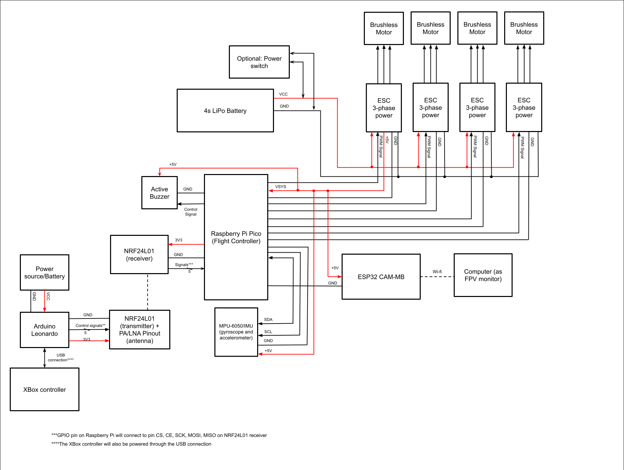

2.2 Sub-Circuit Descriptions

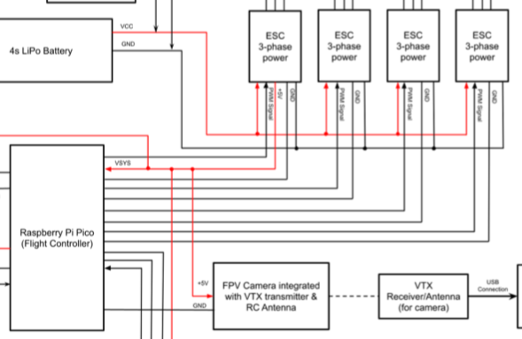
2.2.1 Sub-Circuit #1: ESCs (Electronic Speed Controllers)
4 brushless ESCs will be used to control the throttle of each motor. The Raspberry Pi Pico has limited current (maximum output current of 12mA) and voltage output on its GPIO pin. In addition, it cannot generate the precise three-phase control needed to drive the motors. Therefore, an ESC will be used to control the speed of each motor.

The flight controller (Raspberry Pi Pico) uses PID controllers to determine the necessary adjustments to the speed of each motor to achieve the desired orientation (pitch, roll, yaw) of the drone. This process involves calculating the error between the desired angular rates (from the pilot's input via the Xbox controller) and the actual angular rates measured by the MPU-6050 for each axis. The PID controller computes correction values using proportional, integral, and derivative terms, each scaled by their respective gain values. The sum of these terms provides the control signal for each axis, which is then used to adjust the speeds of individual motors accordingly. Throttle (overall thrust) is managed separately to control altitude, with the PID adjustments superimposed to maintain or change orientation.
The flight controller, utilizing a Raspberry Pi Pico, communicates with each Electronic Speed Controller (ESC) through Pulse Width Modulation (PWM) signals. The duty cycle of the PWM signal dictates the throttle level: a higher duty cycle results in faster motor rotation. Specifically, the PWM signal operates at a frequency of 50 Hz, where a pulse width of 1 ms corresponds to zero throttle and a pulse width of 2 ms signifies full throttle. Throttle adjustments are made incrementally between these two pulse widths.
Each ESC contains a microcontroller connected to six MOSFET transistors—two MOSFETs per motor wire. These MOSFETs function as switches, regulating the current to the motor's three-phase coils. At higher throttle levels, the MOSFETs switch more rapidly, increasing the motor's speed. Between the ESC microcontroller and the MOSFETs lies a gate driver, which amplifies the low-voltage PWM signals from the microcontroller to the high-voltage required by the MOSFETs.
The PWM signals for each ESC (U4-3, U5-3, U6-3, U7-3) are connected to corresponding GPIO pins on the Raspberry Pi Pico (U1-4, U1-34, U1-20, U1-21).
Each ESCs is powered through the 4S Lipo battery and connected to both the battery’s ground and GND pins (U1-3, U1-18, U1-33, U1-23) on the Raspberry Pi Pico. The power and ground wires for the ESC will be soldered directly to the PCB board of the frame.

Unlike a linear BEC, a switching BEC uses a small FET transistor to rapidly switch the battery voltage on and off. This switched voltage is then filtered through an inductor and capacitor to smooth out the ripple, producing a steady DC voltage. This method avoids overheating and reduces power wastage.To avoid buying another separate on-board voltage regulator, the Raspberry Pi Pico will be powered through the VSYS pin (U1-39) by one of the ESCs (U4-4).

2.2.2 Sub-Circuit #2: ESCs, Motors, and Propellers
4 SunnySky 2212 980kv brushless motors will be used, each with a 9450 2-blade propeller.

Compared to brushed motors, brushless motors have minimal friction and are more efficient. 2212 motors are a common and popular motor size for the F450 frame, measuring 22mm in stator diameter and 12mm in stator height - these dimensions allow for a balance in motor responsiveness and cooling.
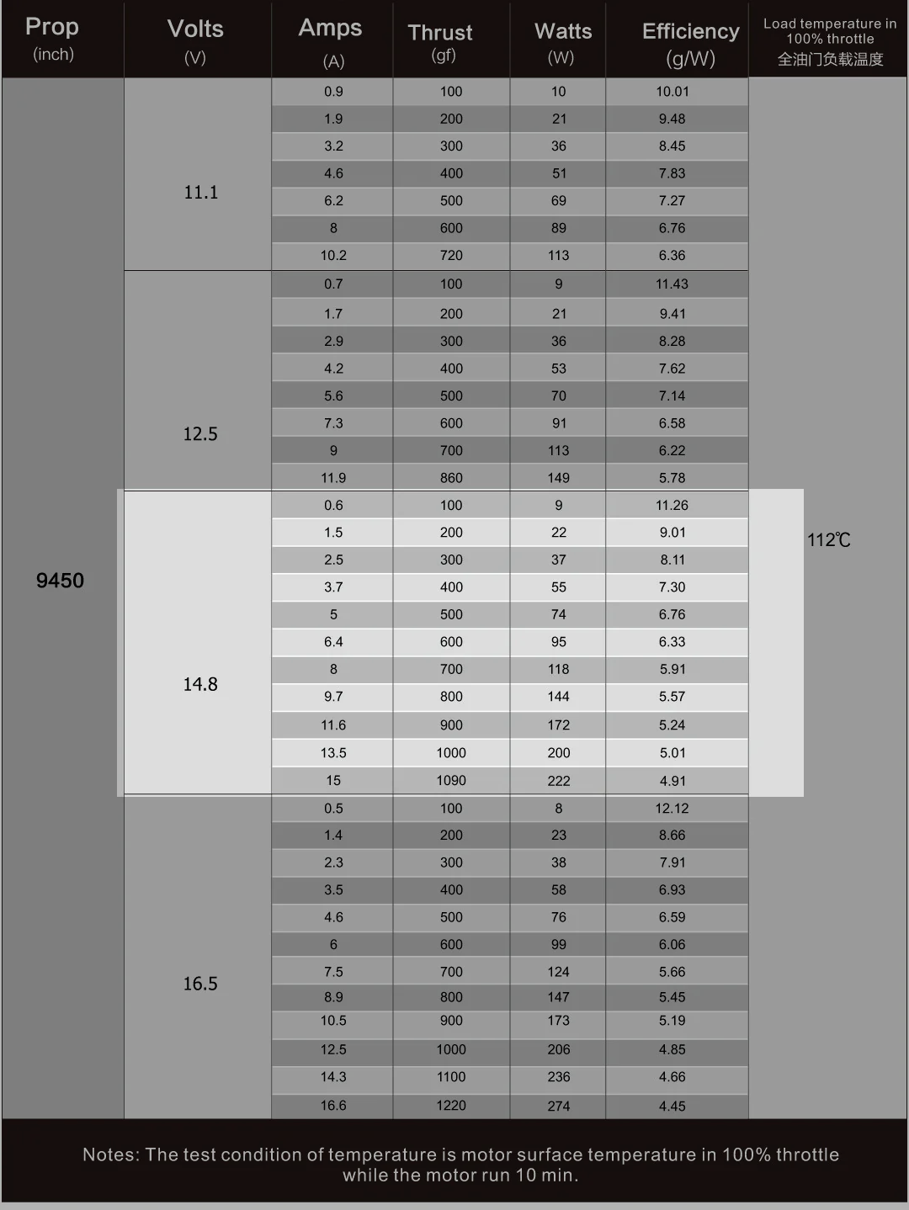
Loaded with all the parts, the drone weighs a total of ~1155g. To achieve a thrust-to-weight ratio of at least 2:1, each motor needs to be able to produce at least 578g of thrust. With a larger frame such as the F450, larger propellers are more suitable as they can move more air and thus generate more thrust. They also provide better flight stability. To generate the greater amount of torque needed to achieve the thrust required for the larger propellers, a lower motor Kv rating is required. This is due to the inverse relationship between torque constant (amount of torque produced per amp of current to the motor) and Kv: $K_{t}(Torque constant) = \frac{1}{K_{v}}$. Since $T(torque)=K_{t}* Current$, a higher torque constant generates more torque, which in turns generates more thrust. Accordingly, based on the thrust table below for the 2212 980v motor, the motor can produce over 578g of thrust with a 4S lipo (14.8V) and 9450 propellers while maintaining fair efficiency.

Each motor will be powered through three phase power from the ESCs. The motor is rated to have maximum continuous current of 20A/30S. Our ESCs are rated for a continuous current output of 30A, well above a 20% increase of the motor’s max current draw, ensuring that the ESCs won’t overheat.

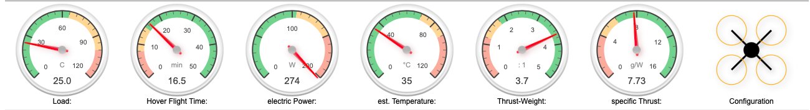
Calculations from ecalc based on components configurations for the drone:
*The results show that the electric power required is over the maximum power rating for the motor. However, this is most likely due to incorrect data from ecalc. Ecalc rates the maximum power limit for SunnySky 2212 980kv motors to be 115W, while SunnySky states that the motor has a maximum continuous power of 330W. Therefore, the motor should be able to generate enough power, and ecalc results are incorrect.

Battery
The drone will be powered by a 4S 3300mAh Lipo Battery, with a minimum discharge rate of 60C and a nominal voltage of 14.8V. This provides ample current and voltage to the ESCs and motors.
$Max Current = Battery Capacity \& C rating$
$Max Current = 3.3 Ah * 60$
$Max Current = 198A$
Each motor has a maximum current draw of 20A: $Max current draw = 20*4 = 80A$
Therefore the battery can safely handle the motor’s current draw. Each ESC is rated for a voltage input of 6.4v - 16.8v.

2.2.3 Sub-Circuit #3: Raspberry Pi Pico and Active Buzzer
The active buzzer with built-in 80mAh Lipo battery will be used for easy identification of the drone amidst crashes or accidents.

If the battery disconnects, the buzzer will sound in low volume for 40 seconds. After 40 seconds, the buzzer will sound at max volume of up to 110db for 40 seconds. The buzzer will flash a blue light in low light settings.

To manually activate the buzzer (if the battery isn’t disconnected):
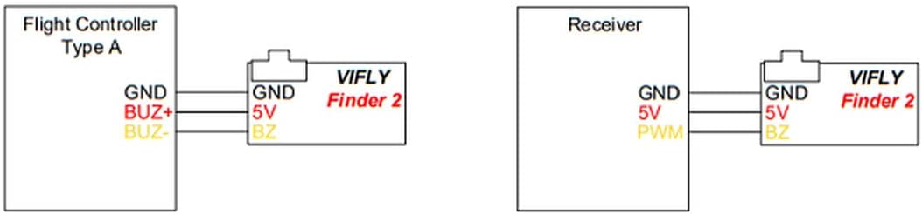
The buzzer activates when current flows from BUZ+ to BUZ-. The buzzer has 3 connections with the Raspberry Pi Pico: BUZ+, GND, and BUZ-. BUZ+ (BZ1-1) is connected to VSYS (U1-39) on the Raspberry Pi Pico. GND (BZ1-3) is connected to GND (U1-28) on the Pico. BUZ- acts as the negative terminal for the buzzer’s internal circuits. When BUZ- is connected to GND, the circuit is complete and current flows through the buzzer, thereby activating it. Due to the limited current that GPIO pins can handle, a 2N7000 MOSFET will be used as a switch between BUZ- & GND. The transistor will be connected to a GPIO 22 (U1-29) on the Pico through a 1 kΩ resistor (to protect the pin from current spikes during switching).
BUZ- will be connected to the drain of the transistor, and the source will be connected to a GND (U1-28) on the Pico. Since the transistor is used as a switch, it will operate only between the cutoff and saturation regions, not the linear (active) region.

GPIO 22 (U1-29) controls the gate voltage, which controls the drain-source channel, but is electrically isolated from the high-current path of the buzzer; the gate draws an extremely small current, protecting the GPIO pin from excessive load. The transistor has a continuous drain current of 200mA, which should be sufficient to handle the buzzer’s current.

When GPIO 22 is set HIGH (3.3V), the N-MOSFET turns on, the gate-source voltage (V_GS) exceeds the threshold voltage required to turn on the MOSFET. The MOSFET enters the enhancement mode and conducts between drain and source. This connects BUZ- to GND, and the buzzer activates.

2.2.4 Sub-Circuit #4: Raspberry Pi Pico and MPU-6050
A MPU-6050 will be used to measure the actual orientation along the three axes (pitch, roll, and yaw) at any time by measuring the drone’s angular velocity and linear acceleration. The MPU-6050 is a six-axis Inertial Measurement Unit (IMU) that combines a three-axis gyroscope and a three-axis accelerometer.

The MPU-6050 communicates with the Raspberry Pi Pico through I2C serial communication protocol. In this case, the Raspberry Pico is the master and the MPU-6050 is the slave. As the MPU-6050 is the only slave on the bus, AD0 will connect to GND (U1-13) on the Pico, setting the I2C address to the default 0x68. To attain specific data or initialize the MPU-6050 for communication, the Pico will write to specific register addresses: 0x6B for power management, 0x3B to 0x40 for accelerometer data and 0x43 to 0x48 for gyroscope data. To read sensor data, the Pico will first send the slave address of the MPU-6050 with a write flag over the SDA line. It will then transmit the specific register address from which it wishes to retrieve data. After setting the register address, the Pico switches to a read flag to initiate data retrieval. An ACK/NACK bit is sent between each command to verify that the request has been received. Data frames are then sent over to the Pico, where a NACK bit from the Pico will stop the reading.

The MPU6050 has an internal built-in low dropout regulator, allowing VDD to directly connect to VSYS on the Raspberry Pi. Since the Raspberry Pico has built-in pull-up resistors for its I2C compatible pins, no external pull-ups are necessary when connecting the SDA and SCL lines. GND on the MPU-6050 is connected to a GND pin on the Raspberry Pi.

2.2.5 Sub-Circuit #5: RF transceivers
Communication between the two RF transceivers is for transmitting the pilot's input for drone movement. It sends the signals from the XBox controller to the drone.
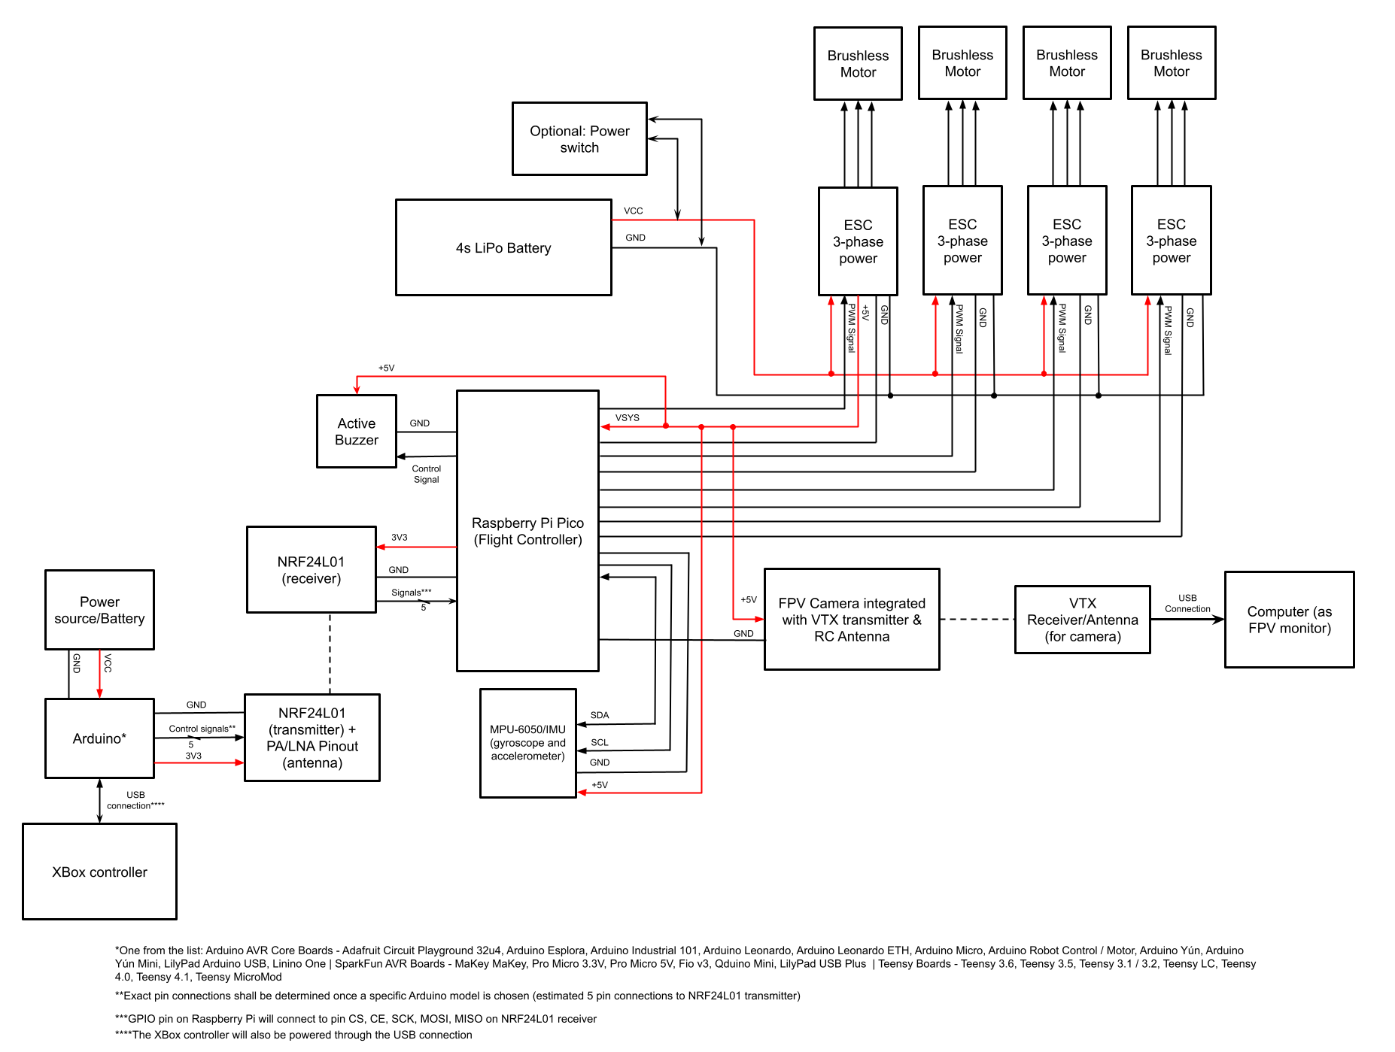
The drone uses two NRF24L01 modules for communication, which is a single chip transceiver that operates on the 2.4GHz ISM frequency brand. Due to its half-duplex design, each module can only send (TX mode) or receive (RX mode) data bus, not both. This module is chosen for its low energy consumption and excellent operational range of up to 1000m.

The nRF24L01 uses a specific frequency, known as a channel, to transmit and receive data. The frequency ranges between 2400 and 2525 MHz, which provides it with 125 (1MHz each) independent RF channels for one module to communicate with other parts. The two RF transceivers must be on the same channel to communicate with each other and the RF channel frequency can be calculated using the following formula:

$Freq(Selected) = 2400 + CH(Selected)$

Therefore if the communication channel between the two RF transceivers we used is 18, then the selected frequency would be 2418MHz.

The nRF24L01 uses the Enhanced ShockBurst packet structure.
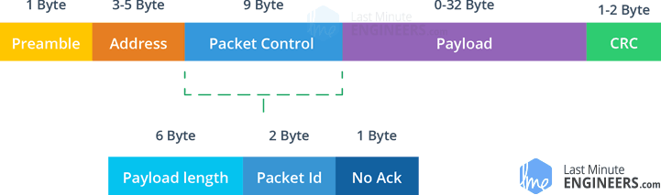
This allows the payload length to range from 1-32 bytes and each packet is assigned a packet ID that allows the receiver to check if the packet is new or has been received.
Each message contains a field asking for the Acknowledgement (ACK). The receiver sends it once the message has been successfully received, eliminating any potential loss of controlling command lost during communication.

2.2.6 Sub-Circuit #6: Raspberry Pi Pico, RF transceiver, and SPI

The RF transceiver on the drone is a wireless communication module that acts as a RF receiver on the drone for receiving the pilot’s input. It has an on-board antenna and obtains signals such as pitch, roll, yaw, and throttle from the other RF transceiver module on the controller and sends it to the flight controller for processing powering of the motors.

The RF transceiver operates at ~12mA during transmission and requires a voltage of 1.9-3.6V. Due to its low power consumption, it can be easily powered using any GPIO pin (U1-7) on the Pico. The transceiver’s GND is connected to GND (U1-8) on the Pico. The RF transceiver outputs signals from pin CE, CS, SCK, and MOSI to GPIO10 (U1-14), GIPO9 (U1-12), GIPO6 (U1-9), GIPO7 (U1-10), in corresponding order.

SPI Communication
SPI, Serial Peripheral Interface, is an interface bus commonly used for synchronous serial communication. It uses separate clock and data lines to send data between a controller and small peripherals.

NRF24L01 communicates via SPI, which makes it compatible with many microcontrollers. It has some changeable registers that need to be configured using 250 kbps, 1 Mbps or 2 Mbps. Some examples of registers include frequency channel and air data rate. Pin MOSI, SCK, and MISO on the RF transceiver are for SPI communication.
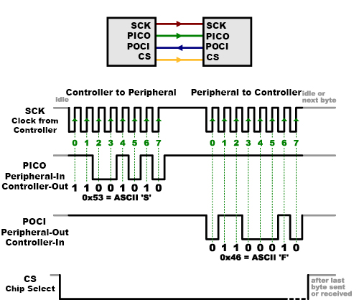
The diagram shows a visual representation of different lines and how it functions.

SCK is used for clock signals that oscillate to indicate the receiver exactly when to analyze the bits on the data line. It can be rising or falling edge detection.

MISO, which also stands for POCI, is for data transmission from the flight controller (Raspberry Pi Pico) to the peripheral (NRF24L01). On the drone it will not be used as we only need to send signals from the Arduino to the Pico.

On the other hand MOSI (PICO) is used for sending data from the NRF24L01 to the Raspberry Pi. When the receiver detects the edge of the clock, it will immediately look at the data to read the next bit.

The CE pin used to control data transmission and enabling RX or TX mode.The CSN pin on the RF transceiver is connected to the Raspberry Pi for chip select line. It tells the peripheral when to receive or send the data and is usually held high, which disconnects the two.


2.2.7 Sub-Circuit #7: Arduino Leonardo and RF Transceiver
The RF transceiver on the controller sends signals of the joystick and buttons to the RF transceiver on the drone. In addition to the NRF24L01 chip, it consists of a duck antenna, PA (Power Amplifier), and LNA(Low-Noise Amplifier), which raise the signal's transmission distance to up to 1000 meters in open space.

Compared to the above subcircuit 2.2.6, it communicates with an Arduino Leonardo instead of a Raspberry Pi. Due to its numerous libraries, an Arduino is easier to work with, such as premade ones for SPI communication and communicating with NRF24L01.

To power the RF transceiver, we connect the VCC (U10-2) pin to 5V (U9-33) on the Arduino Leonardo and GND (U10-1) to GND (U9-34).

Pin CE (U10-3), CSN (U10-4), SCK (U10-5), MOSI (U10-6), MISO (U10-7) connect to the corresponding pins D9 (U9-24), D10 (U9-25), SCLK (U9-9), MOSI (U9-11), MISO (U9-10) on the Arduino.

The RF transceiver communicates to the Arduino via Serial Peripheral Interface (SPI), which is explained in the section 2.2.6.

2.2.8 Sub-Circuit #8: ESP32 CAM-MB
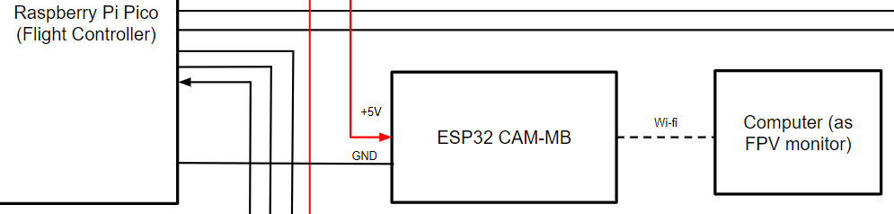
ESP32-CAM-MB provides the camera function for the drone. With a ESP32-S chip and a OV2640 camera sensor, it is able to record video and stream it to the computer. If required, it is also capable of performing image processing because of its 32-bit core microprocessor.
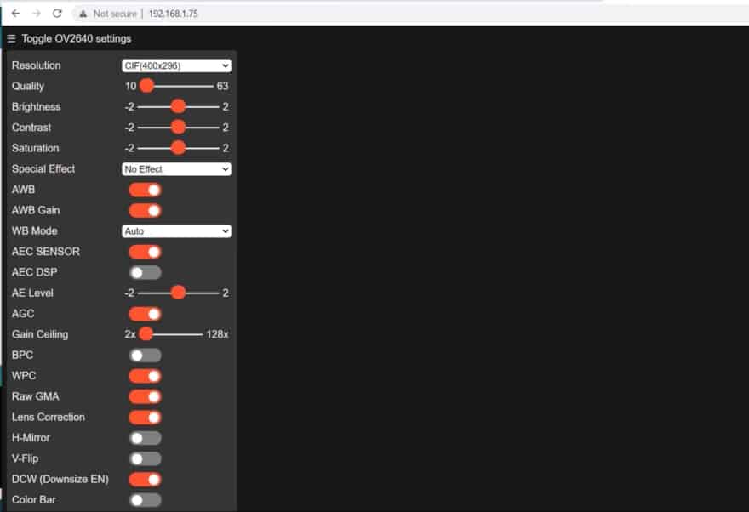
The ESP32-CAM streams the video to a computer via Wifi. It has an on-board PCB trace antenna as well as a u.FL connector for potential connection to external antennas. Since the PCB antenna has a gain of 2.1dBi, which means it can transmit signals to a max of 100m, we would need an external antenna to enhance the range.

The ESP32-CAM is enough for camera purposes, while an additional board with a usb port is added (ESP-32-CAM-MB) to make programming easier. It is only needed to connect the usb port to a computer and the chip could be programmed using Arduino IDE with an existing library. Once the wifi is configured, a live website link would be generated and the image could be viewed there. The left side is an image of the website interface and any additional features that can be modified.

The 3.3V pin (U8-9) on ESP32-CAM-MB connects to the 3V3 pin (U1-36) on the Pico. GND (U8-2) connects to GND (U1-42) on the Pico.

2.3. Product Interfaces

2.3.1 Internal Interfaces

2.3.1.1 Raspberry Pi Pico and ESCs

From | To | Signal Name
U1-4 (GPIO2) | U4-3 | PWM_1
U1-34(GPIO28) | U5-3 | PWM_2
U1-20 (GPIO15) | U6-3 | PWM_3
U1-21 (GPIO16) | U7-3 | PWM_4
U4-4 | U1-39 (VSYS) | VSYS
U1-3 | U4-5 | GND
U1-33 | U5-5 | GND
U1-18 | U6-5 | GND
U1-23 | U7-5 | GND

2.3.1.2 ESCs and Motors
From | To | Signal Name | Description
U4-6 (U) | M1-1 (U) | Phase U1 | Standard connection for CW rotation
U4-7 (V) | M1-2 (V) | Phase V1 | Standard connection for CW rotation
U4-8 (W) | M1-3 (W) | Phase W1 | Standard connection for CW rotation
U5-6 (U) | M2-1 (V) | Phase U2 | Swapped connection for CCW rotation
U5-7 (V) | M2-2 (U) | Phase V2 | Swapped connection for CCW rotation
U5-8 (W) | M2-3 (W) | Phase W2 | Standard connection
U6-6 (U) | M3-1 (V) | Phase U3 | Swapped connection for CCW rotation
U6-7 (V) | M3-2 (U) | Phase V3 | Swapped connection for CCW rotation
U6-8 (W) | M3-3 (W) | Phase W3 | Standard connection
U8-6 (U) | M4-1 (U) | Phase U4 | Standard connection for CW rotation
U8-7 (V) | M4-2 (V) | Phase V4 | Standard connection for CW rotation
U8-8 (W) | M4-3 (W) | Phase W4 | Standard connection for CW rotation

2.3.1.3 4s Lipo Battery and ESCs
From | To | Signal Name | Description
SW1-1 | U4-1 | +BATT | Voltage source
SW1-1 | U5-1 | +BATT | Voltage source
SW1-1 | U6-1 | +BATT | Voltage source
SW1-1 | U7-1 | +BATT | Voltage source
BT1-GND | U4-2 | GND | --
BT1-GND | U5-2 | GND | --
BT1-GND | U6-2 | GND | --
BT1-GND | U7-2 | GND | --

2.3.1.4 4s Lipo Battery and Power Switch
From | To | Signal Name | Description
SW1-2 | SW1-3 | OFF | Power switch is off, no power flow
SW1-2 | SW1-1 | ON | Power switch is on, there is power flow

2.3.1.5 Raspberry Pi Pico and MPU-6050
From | To | Signal Name
U1-39 (VSYS) | U3-13 (VDD) | VDD
U1-13 | U3-18 | GND
U3-9 | U1-13 | ADO
U3-24 | U1-16 | SDA*
U1-17 | U3-23 | SCL
*Bidirectional

2.3.1.6 Raspberry Pi Pico and NRF24L01 Transceiver
From | To | Signal Name
U1-7 | U2-2 | VCC
U1-8 | U2-1 | GND
U2-3 | U1-13 | CE
U2-4 | U1-12 | CS
U2-5 | U1-9 | SCK
U2-6 | U1-10 | MOSI

2.3.1.7 Raspberry Pi Pico and ESP 32-CAM-MB

From | To | Signal Name
U1-36 | U8-9 | 3V3
U1-42 | U8-2 | GND

2.3.2 External Interfaces

2.3.2.1 Arduino Leonardo and NRF24L01 Transceiver
From | To | Signal Name
U9-33 | U10-2 | VCC
U9-34 | U10-1 | GND
U9-9 | U10-5 | SCK
U9-11 | U10-7 | MISO
U9-10 | U10-6 | MOSI
U9-24 | U10-3 | CE
U9-25 | U10-4 | CSN

2.3.2.2 Xbox Controller and Arduino Leonardo
From | To | Signal Name
U11-1 | U10-35 | USB Connection

2.3.2.3 Communication between NRF24L01 Transceivers
From | To | Signal Name | Description
U10 | U2 | RF Transmission | To transmit pilot input from XBox controller to Raspberry Pi Pico
*See subcircuit 2.2.5 for more information

2.3.2.4 ESP 32-CAM and Computer
From | To | Signal Name
U8 | Computer | Wi-Fi*
*There are multiple modes in which ESP 32-CAM can connect to Wifi:
- Station Mode (STA): Connects to an existing Wi-Fi network (like a router)
- Access Point Mode (AP): Creates its own Wi-Fi network for devices to connect directly
- Dual Mode (STA + AP): Operates in both modes simultaneously

2.3.2.5 Battery pack and Arduino Leonardo
From | To | Signal Name
BT2 | U9-8 | +12V

3. Scheduling

3.1 Tasks

Task #1: Drone
(30% ~23 days)
- Order parts
- Calibrate Raspberry Pi Pico (i.e load code) (3 days)
- Create simple programs to test out different parts (2 weeks)
  - Battery
  - Raspberry Pi Pico + ESCs + Motors
    - Power Raspberry Pi Pico through ESCs
  - Calibrate + Test MPU-6050
  - Calibrate + Test Arduino Leonardo & XBox controller
    - Receive data from XBox
    - RF transmission between the RF transceivers
  - Test buzzer
- Assemble parts to frame (1 week)
  - Solder ESCs & battery to PCB board
  - Assemble frame + attach motors and propellers
  - Solder ESC signal connectors to Raspberry Pi
  - 3d Raspberry Pi platform (optional/if needed)
  - Attach all other components
(60% - 47 days)
- Code RF transceiver + Controller
- Code motors + MPU-6050
  - Test without propellers
  - Connect MPU-6050
  - PID tuning
- Code other components
  - Buzzer
  - Power switch (optional)
- Final Testing

Task #2: Camera
(10% ~ 4 days)
- Set up + code camera
  - Get IP address
  - Access the live website
- Assemble it to the drone
- (If have time: Add speed detection/AI program to it)
*Bolden tasks are inputted in the Gantt Chart, unboldened tasks are considered subsections in of the bolded task in the Gantt Chart

3.2 Gantt Chart Schedule
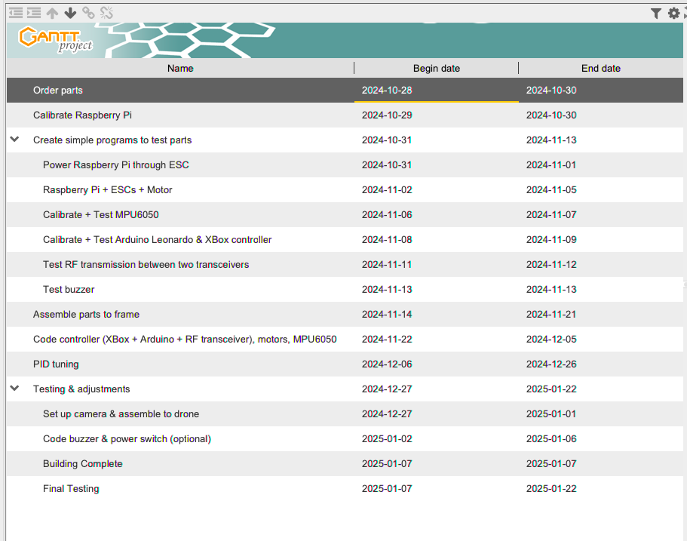
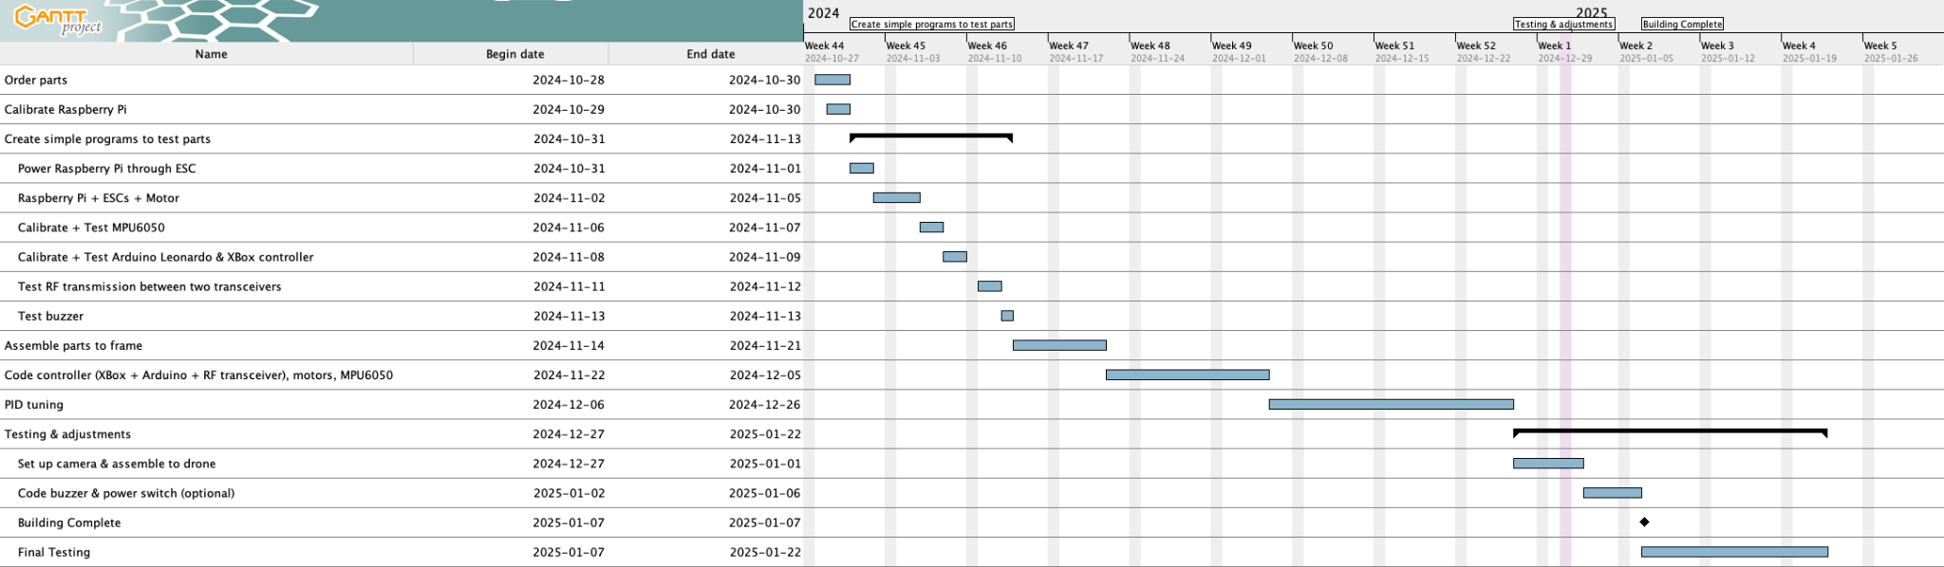
*Also uploaded in assignment submission

APPENDIX

Appendix A. Schematic
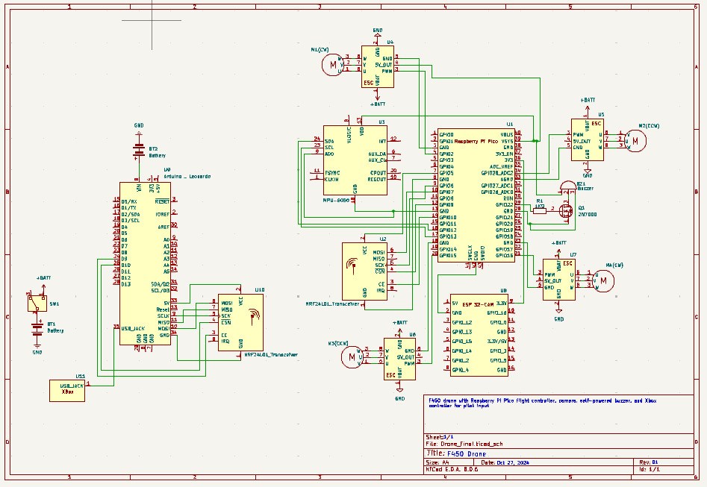
*Not the best image quality, a better quality pdf version is attached to the assignment submission

Appendix B. Parts List
Part Name | Reference Designator | Quantity | Link | Notes
Raspberry Pi Pico | U1 | 1 | https://www.pishop.ca/product/raspberry-pi-pico-non-wireless/?src=raspberrypi | +2$ local pick up fee
MPU6050 | U3 | 1 | Gikfun GY-521 MPU-6050 3 Axis Accelerometer Gyroscope Module 6 DOF 6-axis Accelerometer Gyroscope Sensor Module for Arduino DIY(Pack of 3) EK1091x3C | Pack of 3
ESCs | U4, U5, U6, U7 | 4 | https://www.amazon.com/RC-Brushless-Electric-Controller-bullet/dp/B071GRSFBD?th=1
F450 Frame | N/A | 1 | https://www.amazon.ca/HAWKS-WORK-Quadcopter-Original-version/dp/B09YQ4G4ZZ?source=ps-sl-shoppingads-lpcontext&ref_=fplfs&smid=A2Z91JXWPM95ID&th=1
Buzzer | BZ1 | 1 | https://www.amazon.ca/VIFLY-Finder-Battery-Compatible-Standalone/dp/B07JB65HZC/ref=sr_1_6?crid=33L1LUD0EZMGG&dib=eyJ2IjoiMSJ9.3nt5jgWad25ntm4aNzkUH_lICZMRrpCyhNGjGl9DedHWtZ8auiE4HTLX9TLkCH6Ow0NJFtF057DXWhgy5LZnx8WmmTDi1pROoOVX1y96I5DLjVPFRlGtUvbZTFVM51Mk3z41-1VClFDmt3oOwuitkYkADNPslV68QCR-J0gSm-D1JPpY0HtQai-dIn_uQ2ERvEt-mCHFSfL33XX84dZqqxAk0gSptuEKiS3fn5FlJD1HsDS65ydqMiH1WQSR7tIJgGkVAqJVyxqCjkvKWblneV2Lsj5QNfNhRTLJeCHlQLg.rqkpnmWhzzICaqnN89P_6zeCPlC7tMbltPN1muMmdpU&dib_tag=se&keywords=drone%2Bbuzzer&qid=1730056476&sprefix=drone%2Bbuzze%2Caps%2C102&sr=8-6&th=1
ESP 32-CAM-MB | U8 | 1 | https://www.amazon.ca/dp/B0CGRK4PZ9/ref=twister_B0DG61WS8R?_encoding=UTF8&th=1
NRF2401 transceivers | U2, U10 | 1 | https://www.amazon.ca/diymore-NRF24L01-Transceiver-Development-Compatible/dp/B0CGTWQ1BP/ref=sr_1_2?crid=N7UCP8G6BI4B&dib=eyJ2IjoiMSJ9.QZWyUbxu-TTSXPtYa6jWsruNzInPMMFV3gyAWClyr16MjHZf7YNdMQIuLN8GSAJLMNuq_XRXSs0m0G5N2sjBIhiwK3Z4KvY9esEi6FYL8DDdseyeCPcQ7UDiiZB5kaqveZb2Wb01HFBp9DZ7mam3NE9XG7xw6UoxfQr9Gs2KcmLq1bCmSb6KFCsLg2RbVpZ_.s2cC8epe2nNatPfmenG33v9DyfE5sOt-iBPax3x-Jwg&dib_tag=se&keywords=nrf2401%2Bpa%2Blna&qid=1729738278&sprefix=nrf2401%2Bpa%2Blna%2Caps%2C100&sr=8-2&th=1 | Pack of 3
4S 3300mAh Lipo Battery | BT1 | 2 | https://www.amazon.ca/3300mAh-Battery-Helicopter-Airplane-Quadcopter/dp/B06XKQJZ8D/ref=sr_1_3_sspa?crid=25ULWJT7C7R66&dib=eyJ2IjoiMSJ9.vYiAFw8wx-yRT8mrrvJ9F8iDFepM-goQbSaENXXv1p29dstKtQIYZaj1pn7rGGAGnxdMgoLHrOMQY91OKu51v8WLdjkq4eCi5EKe8z_K4cxcPbNP13Z1RKbgGnhs872aFBYGAh5eJIDjqL14oiAvwBw3eysdwf1lhxGnkO44qkwR113S583LExSDaa1urb2P0Y3cqxNoYUGVdBMDAMReQhU-SncWWSIWO4WEub3ZmS-SjueGbxuDC_AJcCAtAgLVxzIGmlzZL8pKUVzUuEKxSRbdivPCv_PMbDSxuVM6sK4.MMM72QgdE4MEe_CbP1cIRc1AZmN33Ov_NqM5hDzDp8A&dib_tag=se&keywords=4s+lipo+3000mah&qid=1729985037&sprefix=4S+LiPo+3%2Caps%2C81&sr=8-3-spons&sp_csd=d2lkZ2V0TmFtZT1zcF9hdGY&psc=1
Motors (Sunnysky 2212 980kv brushless motors) | M1, M2, M3, M4 | 4 | https://sunnyskyusa.com/products/sunnysky-a2212-motors-multirotor-version?srsltid=AfmBOoppH0aekND_UVhPL1lqfTTU9KIqaeMy3LDPvhpOP_b6vSqr5xUa
Arduino Leonardo | U9 | 1 | https://www.amazon.ca/Leonardo-Headers-Compatible-Revision-Atmega32u4/dp/B00R237VGO/ref=sr_1_5?crid=MC17YS7O9GW9&dib=eyJ2IjoiMSJ9.JMDO9D4vLSrBk_dqVlo-qYpD2emjzeRNG8QL6R8lWGXJUfLWeuU9lkv-AmMXoQJtSdgf6mjRUevYifaj76GKPczdq8-ZPujBm9azFK_jRVBBBxGQ1Iq-UgO_xESHbJL8yc7U0JgTmjihDuHQlgqb1gUqg-HUfgTJJeGmwypsadu_ivg6lFpJP9DrDnsP7rn8GIOX4dFpL6QSGQzulkHG-m7jKz6eSMoNHKHwlVnIjqLFz1WFLYKdxypg1TMg-ZzYmxVo8vHP00SBqcrwLuKwlAzuV_xVFZb3HXRtRz_V0YE.odwVut84lRl1xHouDFEbRF0YtTtdC_Kp_PjlXUqnVfU&dib_tag=se&keywords=arduino+leonardo&qid=1730080008&s=electronics&sprefix=arduino+leonardo%2Celectronics%2C117&sr=1-5
XBox 360 controller | U11 | 1 |  | Already own
Battery Charger |  | 1 | https://www.amazon.ca/Hobby-Fans-Professional-Balance-Discharger/dp/B09XC91BWJ/ref=sr_1_4_sspa?crid=38YSB72VYU6CH&dib=eyJ2IjoiMSJ9.lnM2r6NhD8BJ0diYESu45Q1KQVNPU83hWGmkyM0idZS5APeLiSXCExN5IKIisgJh44yVmbwwP0E7zlbheFz3jKk_iwooFuWlrKiEnSXo5z2Hm1XyjvWMUTACgwu-K6noYPaE1KPmuIRgNc3VBkO0cb2wYWJEtMmLF4PDafVH0bSmUMwI1RbRu4_uRscwDZ7bZEq_wFA83RKeft44gD9qEySyDZEvFfr87CBL2GZFTJcoBO3JMDktAZ_sv86Svj0N_moTYnS4xrkUQI3MXR_SK9aKKv6LZfIlxSP2LDkF9Mw.o5z9RHJirvUDYHafc2uyBP8i3uW1x5a_-s5JsqYVZDc&dib_tag=se&keywords=lipo+battery+charger&qid=1730085173&sprefix=lipo+battery%2Caps%2C103&sr=8-4-spons&sp_csd=d2lkZ2V0TmFtZT1zcF9hdGY&psc=1
9450 Propellers |  | 4 | https://www.amazon.ca/propellers-Self-Locking-Propellers-Quadcopter-Phantom/dp/B0858XGN37/ref=sr_1_3_sspa?crid=2PKGB8ZVQVICU&dib=eyJ2IjoiMSJ9.khREM5zFKF_THptl8e51GLqiBynkBaRAlGZX0G-aQwXK36wY2Yf0tlOGe4blMB8kiDujDkgiEb0yyb-ahszkBvsgk3QV-kH3i3uZ300XqSTO45jxTtJZpAoOSNXMzQAqNiLzC41biQ7gUgm6U4Hf5CxlWLV-0ozpgj44btLPBKyDdzPJI1KdEL_KWK_g-H3CetyPXCkzx3WAe5yc591SpyR-mGiFWfbtE_mUA8DJtqx_fybuHm6o7Zu5MxzEmB7cQZd58T1gNZBor4tOGfg9vivENt9LHX8tyhXV4MuZTJw.Ma1AYF4TXXBscog40srNK_nInWcq-CIVyc7ArsdgvLg&dib_tag=se&keywords=9450+propellers&qid=1730085029&sprefix=9450+propellers%2Caps%2C120&sr=8-3-spons&sp_csd=d2lkZ2V0TmFtZT1zcF9hdGY&psc=1 (for quick shipping)  https://www.aliexpress.com/item/32844447546.html?spm=a2g0o.productlist.main.3.4f2b2e3fBpldJr&algo_pvid=b55a8f97-69bd-4069-bb1c-8dd3c90e7c96&algo_exp_id=b55a8f97-69bd-4069-bb1c-8dd3c90e7c96-1&pdp_npi=4%40dis%21CAD%2113.62%2112.91%21%21%219.61%219.11%21%402101e9a217299675201923501e356e%2166150463925%21sea%21CA%210%21ABX&curPageLogUid=nGstg93h37eM&utparam-url=scene%3Asearch%7Cquery_from%3A (slower shipping) | Ones purchased from Aliexpress will be used during testing stage (cheap and therefore easy to replace if broken)
Battery Pack for Arduino Leonardo |  | 1 |  | Already own

Appendix C. References

Raspberry Pi Pico: https://datasheets.raspberrypi.com/pico/pico-datasheet.pdf
MPU60-50:https://invensense.tdk.com/wp-content/uploads/2015/02/MPU-6000-Datasheet1.pdf

